**How to Run Translation Program:**

After running the translation program, there will be several questions being asked to you on the terminal.

1. **What is the full path of your mRNA channel?** Answering this question is fairly self explanatory but make sure not to include quotation marks in path directory
2. **What is the full path of your peptide channel?** Same as above.
3. **What is the protein channel path (ex. '640S.tif'):** Enter protein channel path here typically 640S.tif. Basically the program needs to know the difference in naming between the mRNA and the Protein file names for the same image. No quotation marks.
4. **What is the protein channel path (ex. '555S.tif'):** Similar to above, the typical mRNA channel path is 555S.tif. No quotation marks
5. **Input treatment labels separated by commas without spaces. To use default input 0:**

(example: CHX,MG132,PuroRep1,PuroRep2,PuroWahsRep1,PuroWahsRep2)

1. **What is the mean of peptide? If you don't know enter 0, if you want to use different means for different images enter -1, otherwise enter the mean for all images:** If you do not know the mean enter 0 and the program will calculate it for you. If you know the list of mean values you would like to use enter -1 and the program will prompt you for the image name list and the mean list. If you want to use a single mean value for all image names enter that mean values

**If -1 was entered the program will ask you further questions**

* 1. **List of image names separated by commas:** provide the program a list of image names that your protein channel has. This functionality should really only be used when copying in mean values previously generated and printed by the program. Example input: '24-03-07_bActinAuxin_CT_001_XY2_640S.tif', '24-03-07_bActinAuxin_CT_001_XY4_640S.tif', '24-03-07_bActinAuxin_CT_001_XY6_640S.tif', '24-03-07_bActinAuxin_MG132_001_XY03_640S.tif', '24-03-07_bActinAuxin_MG132_001_XY07_640S.tif', '24-03-07_bActinAuxin_MG132_002_XY1_640S.tif', '24-03-07_bActinAuxin_MG132_002_XY2_640S.tif'
  2. **List of mean values for file names in the same order as the image names above:** similar to the above question should be copied from previous program run’s print statement. Example input:

258.696, 221.29899999999998, 219.457, 348.189, 257.364, 287.676, 236.732

**Screenshot of output from where the example input above were copied:**

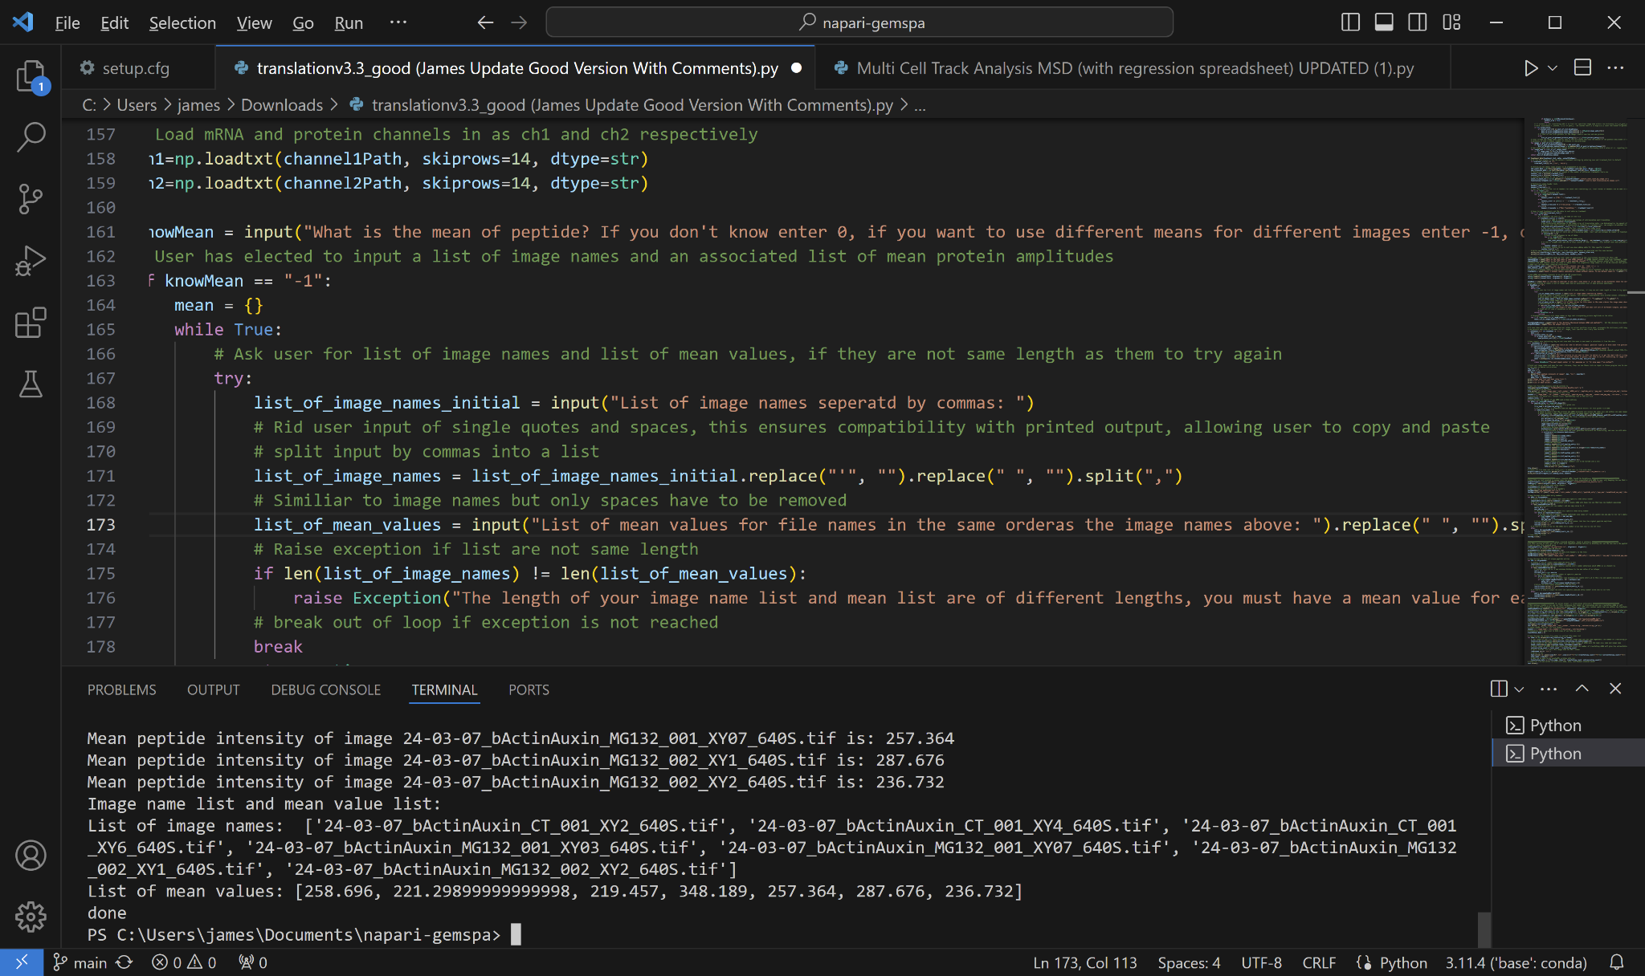

1. **What is the distance threshold between mRNA and peptide?** This can be adjusted based on your specifications but we have been using 700nm (written into the program as 700) to account for chromatic aberration and the sometimes large size of peptide that can cause the center to be further from mRNA than expected.
2. **Save the output file as:** Self explanatory, we have been using result_test.
3. **How many proteins do you want to take the median of to get the amplitude of a single protein:** This question is asking how many proteins you would like to average per image to get the median amplitude of a single peptide. Averaging could potentially increase accuracy but at a cost of time spent running the program. We have been using “500”.
4. **What is the minimum number of points that need to be not translating for image to be included in analysis (minimum number of points averaged to get single peptide amplitude):** Lowest value possible would be one point, which would include any image that has one protein that is not translating that can be taken as the value of a single peptide. It would be advised to use a higher number for better accuracy. Any image that does not meet this requirement will not be included in the spreadsheets.